AGNI BILLING SOFTWARE

USER MANUAL

Table of Contents

1 INTRODUCTION 3

1.1 Purpose 3

1.2 About Agni Billing Software 3

1.3 Key Features 3

2 INSTALLATION 4

2.1 Hardware Requirements 4

2.2 Software Requirements 4

2.3 Getting the Softwares 4

2.4 Installing SQL server Database and .Net Framework 4

2.5 Installing Agni Billing Software 4

3 GETTING STARTED 8

3.1 Launch Application 8

3.2 Login 9

3.3 Change Password 9

3.4 Manage Users 10

4 MANAGE CUSTOMERS 13

5 MANAGE PRODUCTS / DESGINS 14

6 MANAGE BILLING 15

7 MANAGE PAYMENTS 16

8 MANAGE SETTINGS 17

9 SHORTCUT KEYS 18

10 Help 19

Table of Figures

Figure 2‑1 Installation welcome screen 4

Figure 2‑2 Installation folder selection 4

Figure 2‑3 Confirm Installation Dialog 5

Figure 2‑4 Installation progress Dialog 6

Figure 2‑5 Installation Competed Dialog 6

Figure 3‑1 Agni Billing Software Welcome Screen 7

Figure 3‑2 Login Screen 8

Figure 3‑3 Change Password Screen 9

Figure 3‑4 Manage Users – Home Screen 10

# INTRODUCTION

## Purpose

This document is intended to help the user to understand how to install and how to use the Agni Billing Software. Please read carefully all the details from this document to use the software most effectively.

In this document, the terms “Agni Billing Software” and “Agni Billing Application” are used interchangeably and they both mean the same.

## About Agni Billing Software

The Agni Billing Software is a billing management system which runs on windows platform. This software is specifically designed for ‘Agni Designs’ firm based on the customer requirements, but can be used for other customers too with customizations.

## Key Features

* Customer Management
* Product Management
* Billing Management
* Payment Management
* Customized Search and Reports
* Includes GST Provisions
* Secured with User Credential and User Management
* Scalable and Faster with Modern UI
* Easy to use

# INSTALLATION

## Hardware Requirements

Hard Disk / Physical Storage (Free Space Required): 4 GB

RAM (Total available): 2 GB

## Software Requirements

Microsoft SQL Server Express 2014 or Later.

Microsoft .NET Framework 4.5 or Later

SAP Crystal Reports runtime engine for .NET Framework

Agni Billing Software

## Getting the Softwares

Except the Agni Billing Software, the other softwares can be found on internet or purchased from the respective manufacturers. Agni Billing Software is provided by ElangoTechnologies.

## Installing SQL server Database and .Net Framework

Installing the SQL Server and .NET Framework is little tedious process and it is not covered in this document. This is not covered here because it is generic and not specific to Agni Billing Software. The installation procedure for these softwares are available on the web widely and can be followed.

## Installing Agni Billing Software

The step by step guidance are given below.

Launch the setup by double clicking the “Setup.exe” file which is given for Agni Billing Software.

Welcome screen will be shown as in below.

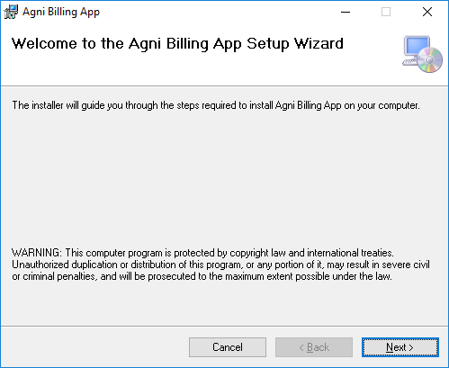

Figure 2.5‑1 Installation welcome screen

Click “Next”. Next option would be selecting installation folder in your system.

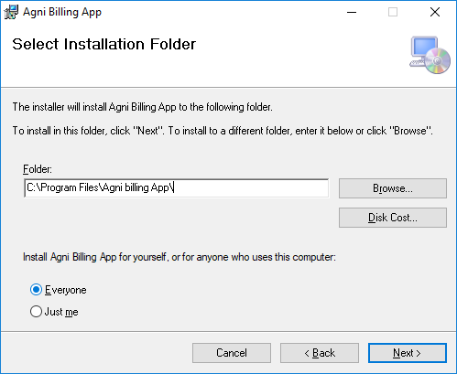

Figure 2.5‑2 Installation folder selection

Once the desired installation folder is selected then click “Next” Button. Installation confirmation dialog will be shown now.

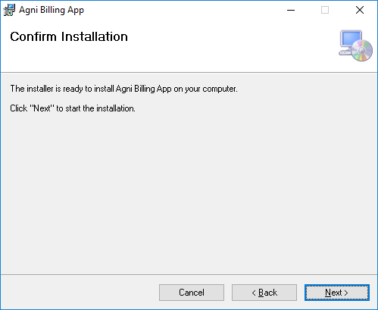

Figure 2.5‑3 Confirm Installation Dialog

Click “Next”. If system warns about this application is trusted or not, just click “OK”. Then the installing progress will be shown.

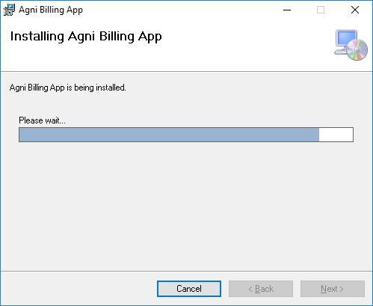

Figure 2.5‑4 Installation progress Dialog

Once the application is installed, you will get the installation complete dialog.

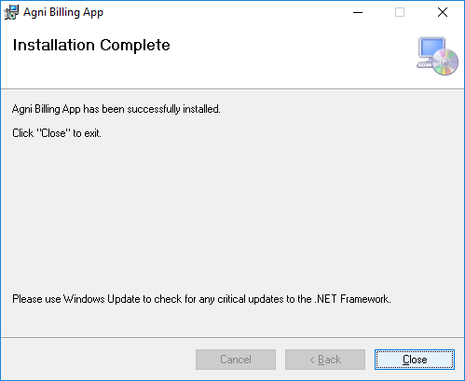

Figure 2.5‑5 Installation Competed Dialog

Click “Close”. Now the Agni Billing Software is installed in your system successfully. This will create an entry in start menu and also a shortcut on the desktop. The entry name will be “AgniBillingApp” and using this the Agni Billing Software can be launched.

# GETTING STARTED

## Launch Application

The application can be launched either from start menu entry or from the desktop shortcut. Whenever the application is launched you will be greeted with the following welcome screen. Once this welcome screen dismissed automatically between 2 to 3 seconds, the Login screen will be followed immediately.



Figure 3.1‑1 Agni Billing Software Welcome Screen

## Login

In Login screen, you can either select one of the available users from the list or manually type the user name. Once selected/entered the user name then you should enter the respective password for that user.

Now clicking on the “Login” button or pressing “Enter” key would validate the username and password and if the entered data are correct you will be taken to the main application screen. This will be discussed in-detail in a separate section.

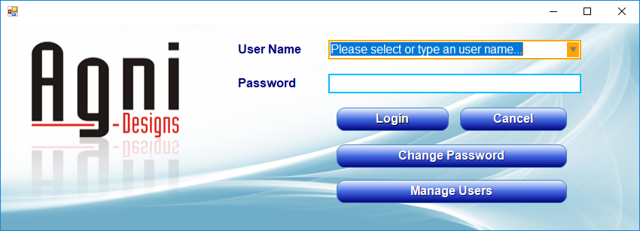

Figure 3.2‑1 Login Screen

When you click the “Change Password” button you will be taken to the change password screen.

When you click the “Manage Users” button you will be taken to the User Management screen. But you must enter a valid user name and password before clicking on the “Manage Users” button. Only if they are valid then you will be allowed to proceed.

**Keyboard Shortcuts:**

Enter – Login into the application. Clicking on the “Login” button would do the same.

Esc – Close the Agni Billing Application. Clicking on the “close” button on the top-right corner or clicking on the “Cancel” button also would do the same.

## Change Password

To change the password, you need to enter valid username and then respective old password. Then you need to enter the new desired password in New Password field. Repeat the same password in Re-Type Password field. They must be same. When you click on “Confirm” button or press “Enter” key, the application will validate all the details that you have provided. If the validation is success then the password will be updated in the system. From that time onwards you need to use new password for login.

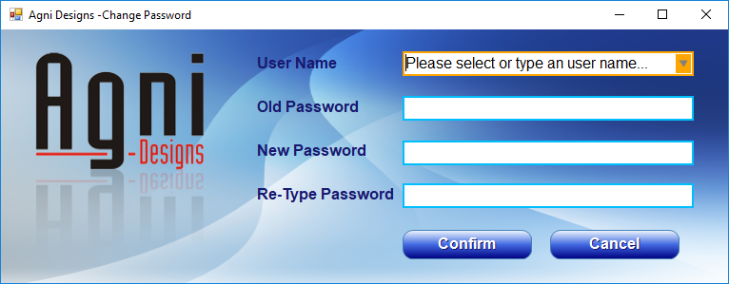

Figure 3.3‑1 Change Password Screen

**Keyboard Shortcuts:**

Enter – Confirm the password update. Clicking on the “Confirm” button would do the same.

Esc – Close the Change Password screen and bring back the Login Window. Clicking on the “close” button on the top-right corner or clicking on the “Cancel” button also would do the same.

## Manage Users

You need to provide the user credentials to enter into this screen.

There are two type of users. 1) Administrator 2) Guest

If you are an administrative user then you will have privileges to create, update and delete user. Guest users only can view the users, but cannot modify them.

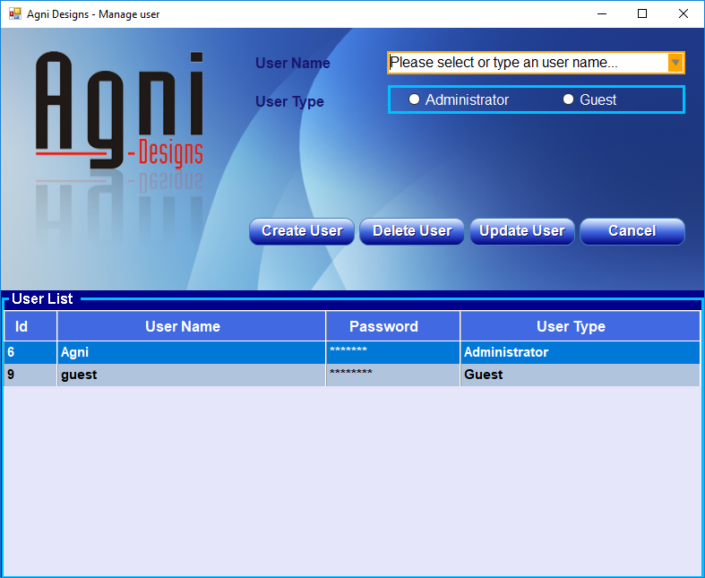

Figure 3.4‑1 Manage Users – Main Screen

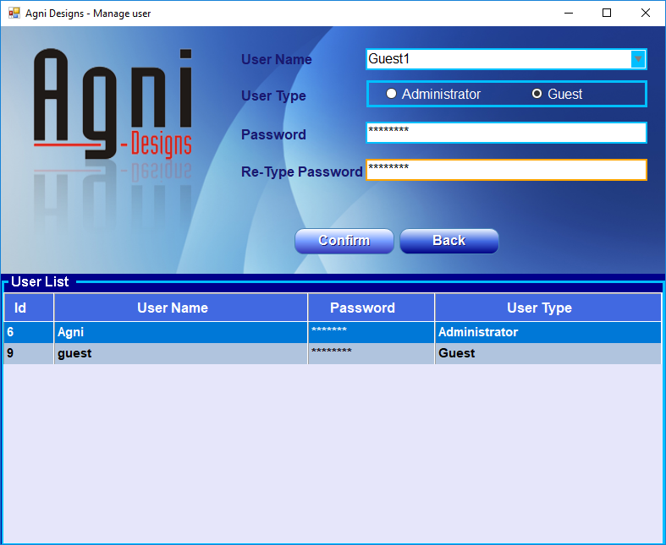

Figure 3.4‑2 Mange Users - User Creation Screen

**Keyboard Shortcuts:**

Enter – Shows Create User screen. Pressing Enter key again in Create User screen will be considered as “confirm” button clicked for confirming the user creation.

Esc – Close the Manage Users screen and bring back the Login Window. Clicking on the “close” button on the top-right corner or clicking on the “Cancel” button also would do the same.

# SOFTWARE OVERVIEW

## The Main Screen

When you enter into the application after successful login, you will be seeing the application Main Screen. The main screen is split into 7 tabs where each tab represents a screen and each screen is to manage a specific set of related operations.

The 7 screens are listed below

1. Customers
2. Designs
3. Billing
4. Payments
5. Reports
6. Settings
7. Help

Each of these screen are explained in detail in upcoming sections.

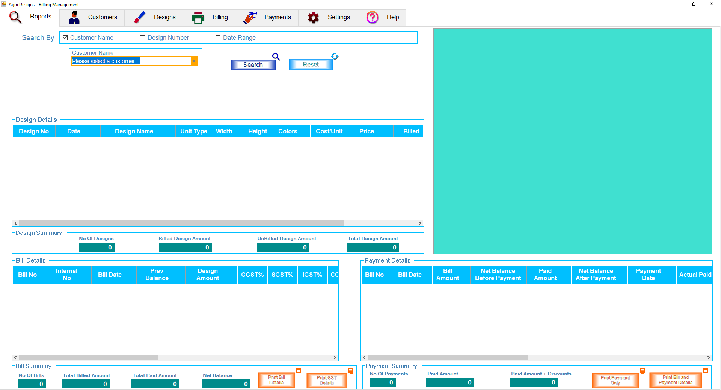

Figure 4.1‑1 The Main Screen after login

When you close this application by Alt + F4 or by clicking the cross button on right top corner, the application will show confirmation dialog to confirm the closing.

## Keyboard

**Alt + R or Alt + 1** – Reports screen will be shown

**Alt + C or Alt + 2** – Customers screen will be shown

**Alt + D or Alt + 3** – Designs screen will be shown

**Alt + B or Alt + 4** – Billing screen will be shown

**Alt + P or Alt + 5** – Payments screen will be shown

**Alt + S or Alt + 6** – Settings screen will be shown

**Alt + H or Alt + 7** – Help screen will be shown

# MANAGE CUSTOMERS

## Description

Using the customer screen, you can manage the customers. Managing customers includes creating, modifying and deleting the customer records in the application. In this screen customer contact details like the address, phone and email id are captured. Other customer specific data like the GST percentage, design cost per unit also captured in this screen.

All the customer records will be shown in a table in the bottom of the *Customers* screen.

Whenever you add, update or delete any customers from this screen, the updated data will reflect in the customers table shown at the bottom of this screen and also in all other screens wherever customer records are shown.

Fields which are mandatory are marked with an asterisk symbol (*) next to the field description. You must enter the mandatory fields to create a customer record. Otherwise the software will show the error and will take the focus directly to the missing field.

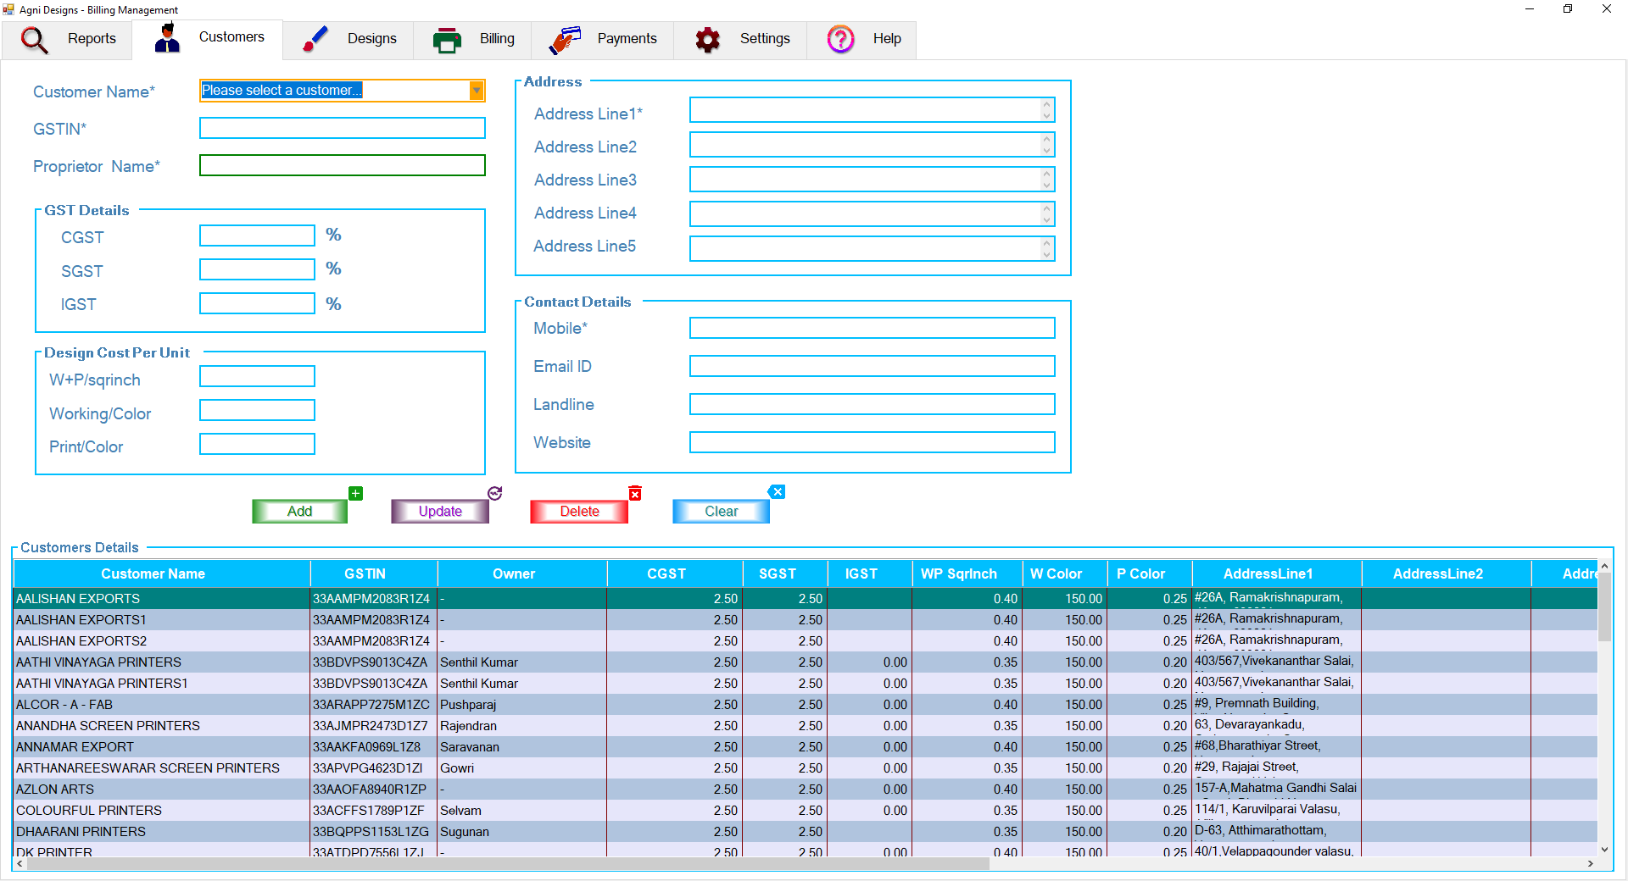

Figure 5.1‑1 Manage Customers Screen

## Permission

Only administrative users can create, update and delete the customer records.

The guest users can only view the customer details, but cannot modify it.

## Selecting a Customer

You can select a customer from the first field described as “Customer Name”. Either you can select one of the items from the drop down list or you can directly type the customer name. When you start typing the customer name, the field will filter and show only the customers who matches with the typed text.

You can also select a customer by clicking on a row from the customers table shown in the bottom of the screen.

Whenever you select a customer as described above, all the details of that customer will be populated and shown in the respective fields.

## Creating a Customer

## Caution

Deleting a customer from Customers screen will remove all the related data which belongs to that particular customer. This includes the customer contact details, designs, bills and payments for that customer. This is operation is not reversible, so please take precautions before performing this operation.

When you attempt to delete the customer, the software will warn you about the deletion and also will ask for administrative user credential to perform this operation to avoid the accidental deletion.

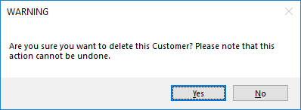

Figure 5.3‑1 Warning Message for Deleting Customer

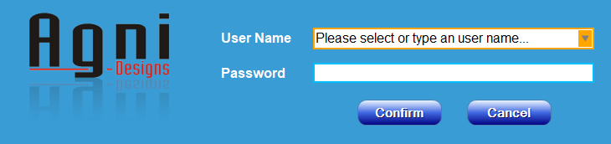

Figure 5.3‑2 User Validation for Deleting Customer

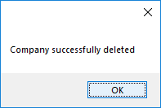

Figure 5.3‑3 Customer Deleted Confirmation

## Keyboard

TAB Key – Pressing “Tab” key will move the cursor focus to next field in the *Customers* screen. This will help you to traverse through all the fields in the *Customers* screen and enter the data without using the mouse.

Enter Key – Pressing “Enter” key will add the customer, if all the mandatory fields are filled.

# MANAGE PRODUCTS / DESGINS

# MANAGE BILLING

# MANAGE PAYMENTS

# MANAGE SETTINGS

# REPORTS

# Help